Process decomposition and AI insertion points
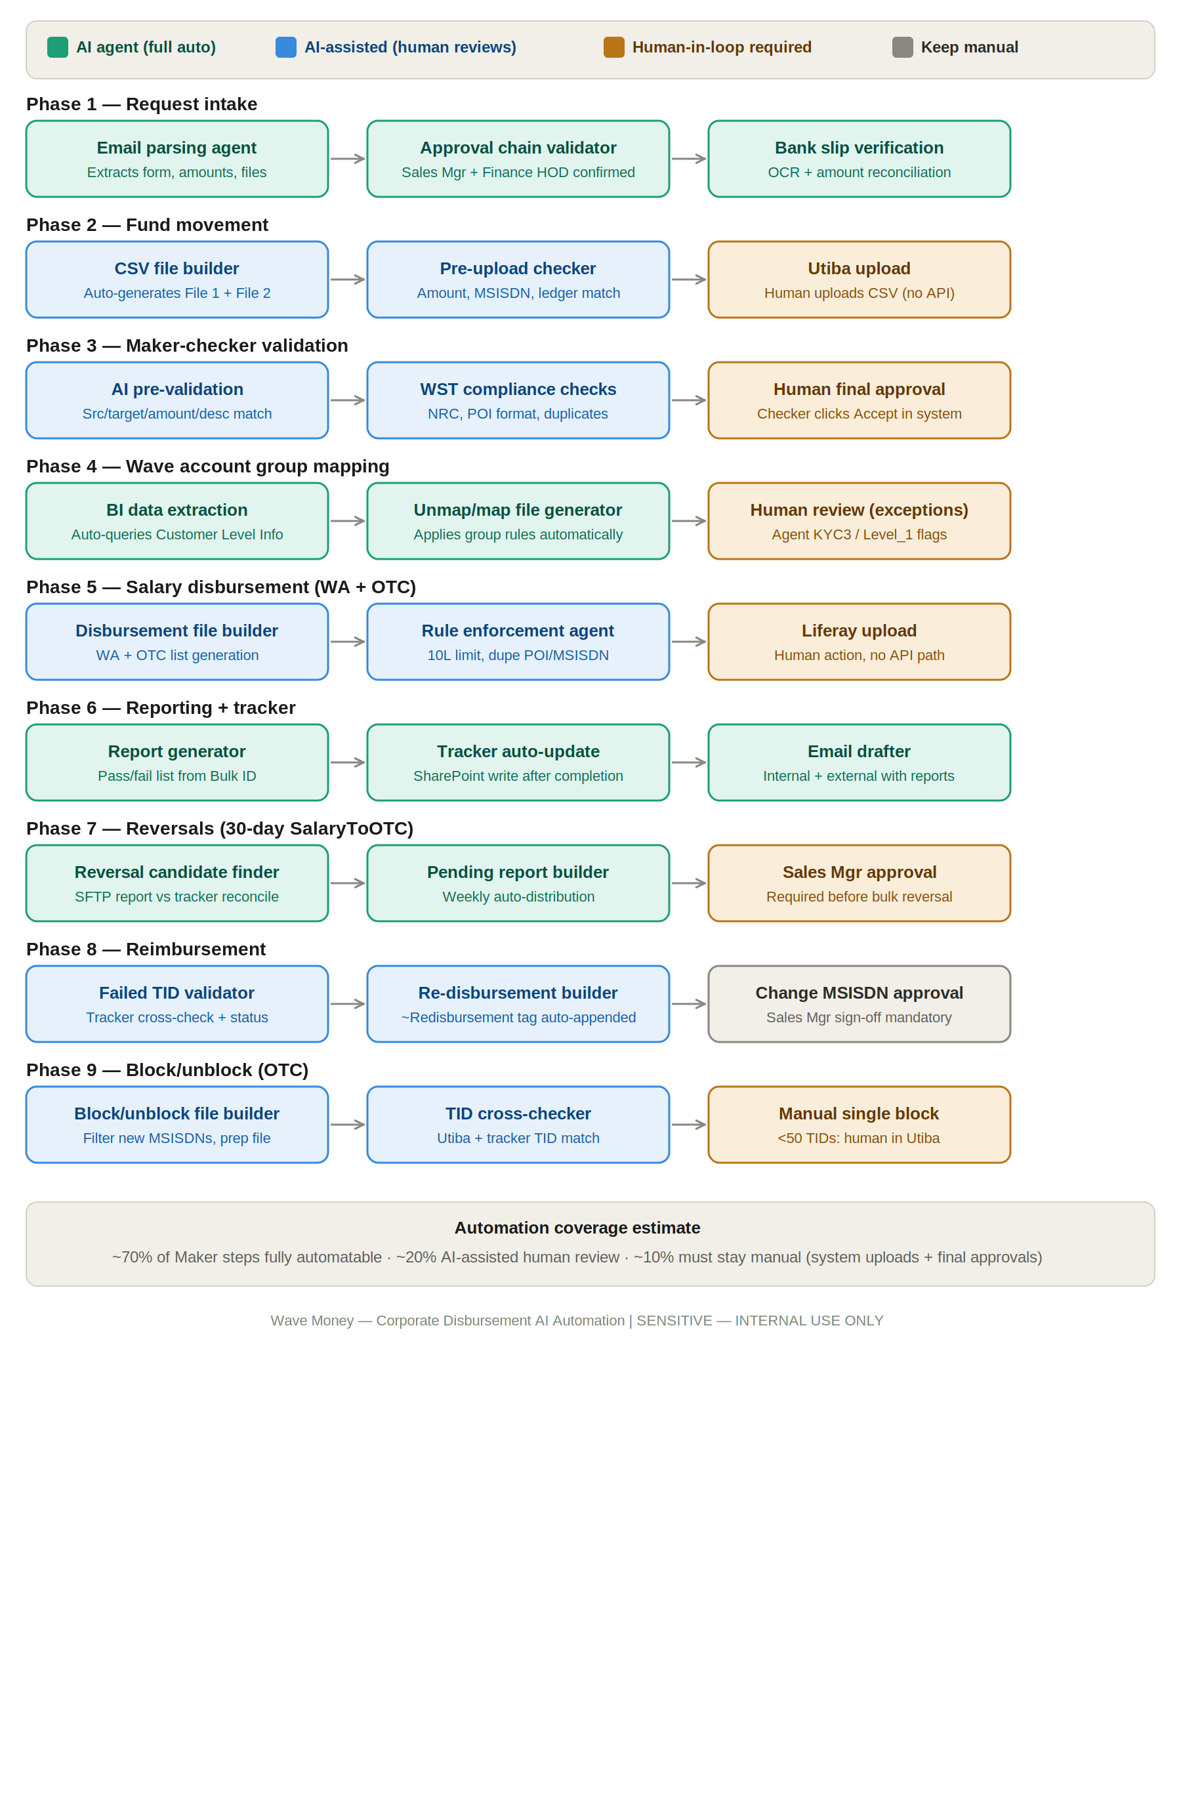

Phase-by-phase AI insertion
Phase 1 — Request intake (fully automatable) Currently: Maker manually keeps emails, re-reads the approval form, checks bank slips against the form, checks that both Sales HOD and Finance HOD approvals are present.
AI agent does: parses the incoming email and attachments, extracts amount, client name, MSISDN list, and approval metadata, OCRs the bank slip and confirms amount matches the form, validates that required approvers have signed off, flags anything anomalous before any human touches it. The Maker's first action becomes reviewing a structured, validated summary — not reading raw emails.
Phase 2 + 5 — File preparation (AI-assisted, ~80% effort reduction) Currently: Maker manually builds File 1 (DMM Wallet → Disbursement Ledger) and File 2 (Disbursement Ledger → Corporate Wallet) in Excel, then converts to CSV in the correct format. Same for SalaryToMA and SalaryToOTC files.
AI agent does: takes the approved MSISDN list + amounts from the parsed intake, auto-generates correctly formatted CSV files for each transaction type, including the appended description conventions (~Redisbursement, ~MSISDN Change). Maker reviews the generated files and uploads — that's it.
Phase 3 — Maker-checker validation (AI-assisted) Currently: Checker downloads the CSV from Utiba/Liferay, manually cross-references every field against the original approval form, checks approvals, validates amounts.
AI agent does: runs the same validation programmatically — source account, target, amount, description, approval match — and presents the Checker with a pass/fail summary with highlighted discrepancies. Checker's job becomes reviewing exceptions, not re-reading every row. The actual approval click in Utiba stays human (no API, and this is the right control point to keep).
Phase 4 — Wave account group mapping (fully automatable) Currently: Maker manually logs into Power BI, searches each MSISDN, checks the Latest_Group_Map column, prepares unmap + map bulk files based on the corporate agreement database.
AI agent does: queries the BI report API with the MSISDN list, retrieves group status, cross-references the Corporate Agreement Database to determine correct group assignment, generates the unmap + map files. Exception flags (Agent category, KYC Level 3, Level_1) trigger a human review prompt rather than auto-processing.
Phase 6 — Reporting and tracker updates (fully automatable) Currently: Maker checks status via Bulk Upload ID in Utiba, takes screenshots, generates report in Liferay, manually types tracker entry in SharePoint, writes internal and external emails.
AI agent does: polls Liferay for the bulk report by ID, parses pass/fail status, generates the formatted transaction report, drafts internal and external emails in the correct format (with the password-protection instruction for OTC reports), writes the tracker entry to SharePoint, and archives to the date-structured Share Drive folder. The Maker reviews and sends — not composes.
Phase 7 — Reversal identification (fully automatable) Currently: Maker manually downloads the SFTP report, does Excel VLOOKUP reconciliation against the tracker, identifies 30+ day pending transactions, emails the Sales team, waits for Sales Manager approval.
AI agent does: scheduled task (e.g. every Wednesday) downloads the SFTP file, runs reconciliation against the tracker automatically, generates the pending transaction report, and routes it to the Corporate Sales Team with the approval request. After approval is received, the reversal CSV is generated ready for upload.
Phase 8 — Reimbursement (AI-assisted) This is the highest-risk process because it involves correcting failed or successful transactions. AI validates the TID against the tracker to confirm the failure status, generates the re-disbursement file with the correct description tagging, and flags the MSISDN Change variant for mandatory Sales Manager approval before file generation. The human reviews the AI's validation output before upload.
Phase 9 — Block/unblock (AI-assisted for bulk, stays manual for <50) The SOP already makes this distinction: bulk (50+ TIDs) uses Utiba bulk upload, individual uses the manual portal. AI generates the filtered MSISDN list and bulk file for the bulk path; the <50 case stays in the portal.

What must stay human
Three things are genuinely non-negotiable:
- The actual Utiba/Liferay file uploads — there is no API path. The AI prepares a validated, ready-to-upload file and tells the human exactly where to go and what to click. You're reducing this to a mechanical action, not a judgment call.
- Final Checker approval click — this is the control point. It should remain a named human taking a deliberate action in the system. What changes is that the Checker arrives with AI pre-validation complete, so they're reviewing exceptions rather than re-doing the Maker's work.
- Reversal approvals and MSISDN Change reimbursements — both require Sales Manager sign-off by policy. AI routes the request and generates the file ready to go pending that approval.

